Let’s save the memory, part one
Do you want to learn how did the pre-war Mszana Dolna look like? Who were Jurek Streimer, Rachelka Repun and Lusia Beldegrün? What did the pre-war boys called “palate”? Listen to the story told by one of the last witnesses, set out on a journey to the world of memories… That’s how your home town looked liked…

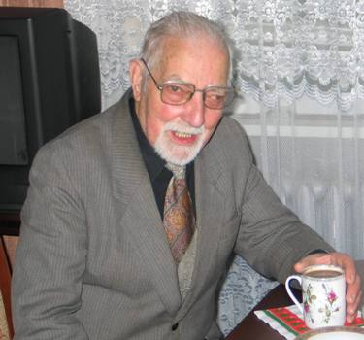
Mr. Henryk Zdanowski tells us about Mszana Dolna before Holocaust
When World War II began, I was only 15 years old. However, I remember very well the war and pre-war Mszana which was a mixture of Christian and Jewish culture, because quite a big percentage of Mszana Dolna citizens were Jewish. I am not able to say how many Jewish people used to live here but I am sure there used to be a lot of them. Jewish houses stood almost everywhere: on the Market and on the main streets as well as in the suburbs and in the nearby villages. And at school, in my class there certainly used to be about 10-15 Jewish students. As I remember, this biculturalism was something absolutely natural and after the Holocaust, when the Jewish people completely disappeared from the town’s landscape, I could not get accustomed. But start right from the beginning. I was born in 1924 in Mszana Dolna as the youngest, eighth child in my family. Primary school I attended for the first three years, had been situated in the building where, later, a dormitory block used to be. I hade a really close and kind friend there whose name was Jurek Streimer. His father was a well-known lawyer, a Jewish man. I remember him as a really good man. The Streimers had three children: the eldest, Janka, was a friend of my sister Marysia. The following were Henio and the youngest Jurek. Because this family lived closely to my school – they had owned a house on the Kolbe Street which was later bought by Mr. and Mrs. Jania) – and they were very kind people, I often visited their house. Jurek’s mother used to invite me many times for a lunch as she knew that my family wasn’t a very rich one with eight children to bring up. Streimers’ house was absolutely normal, assimilated. I mean their wear clothes similar to clothes of Christian people – no black, long coats, foxlike caps or little, round caps, called “palates” by me and my friends, that ortodox Jews used to wear.

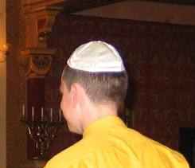Skullcap (kipa), called “palate”
Yes, there also used to be a lot of such ortodox Jews in Mszana – for example bearded and wearing payots dressmaker from Market who made a perfect school uniform for me in just one day. But Streimers’ house was absolutely normal. Once, during Christmas, I even saw the Christmas Tree there! Later I met Streimers in Lwów. It was at the beginning of war. I know they survived but they have never come back to Mszana Dolna after they had gone somewhere abroad.
My another Jewish friend from school whom I remember very well was Lusia Beldegrün. To this day I still see her dark, beautiful, curly hair and hear the words of poem she was declaiming at one of school parties: ‘ I saw a butterfly shaking on the leave’. She attracted me very much and I was in love with her. Lusia’s father owned a bakery opposite to Mr. Gocał’s house. Delicious, long bread was baked there. There used to be plenty of Jewish bakeries in the pre-war Mszana and all of them were absolutely perfect. To this day I remember taste of this bread! In the corner of the Market Jews baked round bread. In the second corner, close to catholic church it was able to buy sweet, delicious rolls. Another bakery was ran by Jew Markus and his sons. It was located in the building of later bakery. Today it is used as a drugstore. I remember also a special bakery where matzoth, unleavened bread for Pesach, was made. It was situated in the Market, in a court, behind the present “Osmed” clinic and the house of Mr. and Mrs. Sitkowski. Local famous violinist, Urysh who was of course a Jew, owned it. No wedding party could take place without this brilliant musician. I remember he used to purchase skins of little animals, too. He had a very big family and a lot of children. The Jews sometimes offered matzoth to me, especially about time of Pesach. It tasted great, especially with a little of butter.
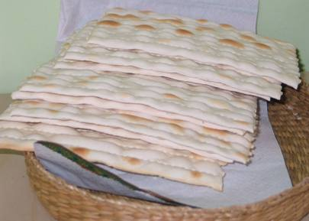Matzoth, passover bread.
Not far from Urysh’s bakery there was a cheder, school where Jewish kids used to learn Talmud, was. The kids used to declaim the Talmud aloud so you could hear them through the open windows. One time my another Jewish friend, Józiu Synaj, invited me to this “hayder”, as I used to call it. Józiu’s family traded alive fish, they have a shop near the present “Meblomet”. I quite often helped him with carrying those fish to the customers.
I took further education in a school close to cheder. Today there is primary school nr 2. Next to this school was the synagogue, place where the Jews prayed. One time one my Polish colleague from school even threw a dead bird through an open window inside the synagogue. But the head-teacher immediately punished him – for such things there wasn’t any tolerance. The Christian and the Jewish societies got on well one with another, and however, from time to time several vandals’ acts of violence happened, they were immediately punished, the police kept watch on it.
I remember that some of my Jewish schoolmates even used to stay at school at Catholic religion lessons. And during the holidays like the 3rd of May, the 11th of November and the 19th of March – the name-day of Marshal Piłsudski – they celebrated the same way as the Christian citizens and we, Christian and Jewish children, used to go to the church together that days!
We had Jewish neighbors who were called Repun. They ran a grout & flour-shop on the Pilsudski Street. I remember, just like it would be yesterday, a shield with golden letters on black background: “SIAPSY DAWID REPUN, GROUT AND FLOUR SHOP”, and written in smaller letters: “Kózka”, the surname of a man who had made that shield. Mrs. Repun, common called “Repunka”, used to visit us quite often in order to exchange fertilized, not kosher eggs. We helped each other many times and I had a special place in a heart of their little daughter, Rachelka (Rachel). When she didn’t want to eat something, she used to say: ‘Let Henio (pet name of Mr. Zdanowski) come and I will eat’. So Mrs. Repun asked me to come, and when I came Rachelka ate. One time Mr. Repun offered me “szabasówka” (that means in Polish ‘a Sabbath drink’ ), a kind of Jewish herbal vodka. I didn’t feel like drinking but I couldn’t say ‘no’ to this older man. After that, at home, when I told to my parents I had drunk vodka I wasn’t, however, punished, because everyone thought that “szabasówka”, although being alcohol drink, is rather healthy. The Repuns family luckily survived the Holocaust, because they had emigrated abroad before the war. I remember the names of their sons: Hesiek and Pinek. The third son was a cantor at synagogue in Będzin, he sang beautifully. I heard his singing at the only Jewish wedding party I took a part in, at the Beldegrüns’. Everything was very beautiful, the newlyweds were standing under a huppa, everybody were breaking glasses and calling ‘Mazeł tow!’, what meant ‘Good luck’. Anyway, could the newlyweds live happily? Short after this wedding World War II began. I still see the faces of those people who I knew so well and who are no longer a part of our town’s landscape. Mr. Landau who had a fabric shop in the Market. Mr. Lilienthal, the owner of a luxury restaurant and hotel, located in a place where today the house of Szynaliks’ family is, next to the bus station. Mr. Wienberger who ran a restaurant in a place of present “Lubogoszcz”. The Langsams family who were very rich men but also helped the poor men many times. The fat Mrs. Hesiek selling seeds and food articles who liked sitting in a front of her shop. Mojsie Śmilka and his small shop with fashion accessories on the Pilsudski Street. Mrs. Feuerstein, commonly called “Fajersztanka”, the owner of another fashion shop. Jewish glazier from the Market whose name I don’t remember. Zelek, who had a store of scrap metal and his daughter, Sura (certainly Sarah), having some problems with speaking correctly and was quite disabled at all. She always leaded a poor pony pulling a car. The boys used to call her “Sura, Sura”. Mr. Wolf, the owner of a food shop at Słomka. Mr. Burek – in his shop we used to buy kerosene and grease. Mr. Sznajer who had four beautiful daughters. The others wonderful girls, hat-makers, had had their studio in a house where, later, Bielinścy family lived. For little money they remade an old, grey hat for me. They used to walk to the beach, quite often with three boys from Elusie /Turner family/ who were able to catch alive fish using only their hands. The other Elusie had a disabled son, Szlomo. There were plenty of people whose name was Elusie in Mszana Dolna and there is still one of many houses where they lived: between the Market and the fire station. It’s a small, wooden house.
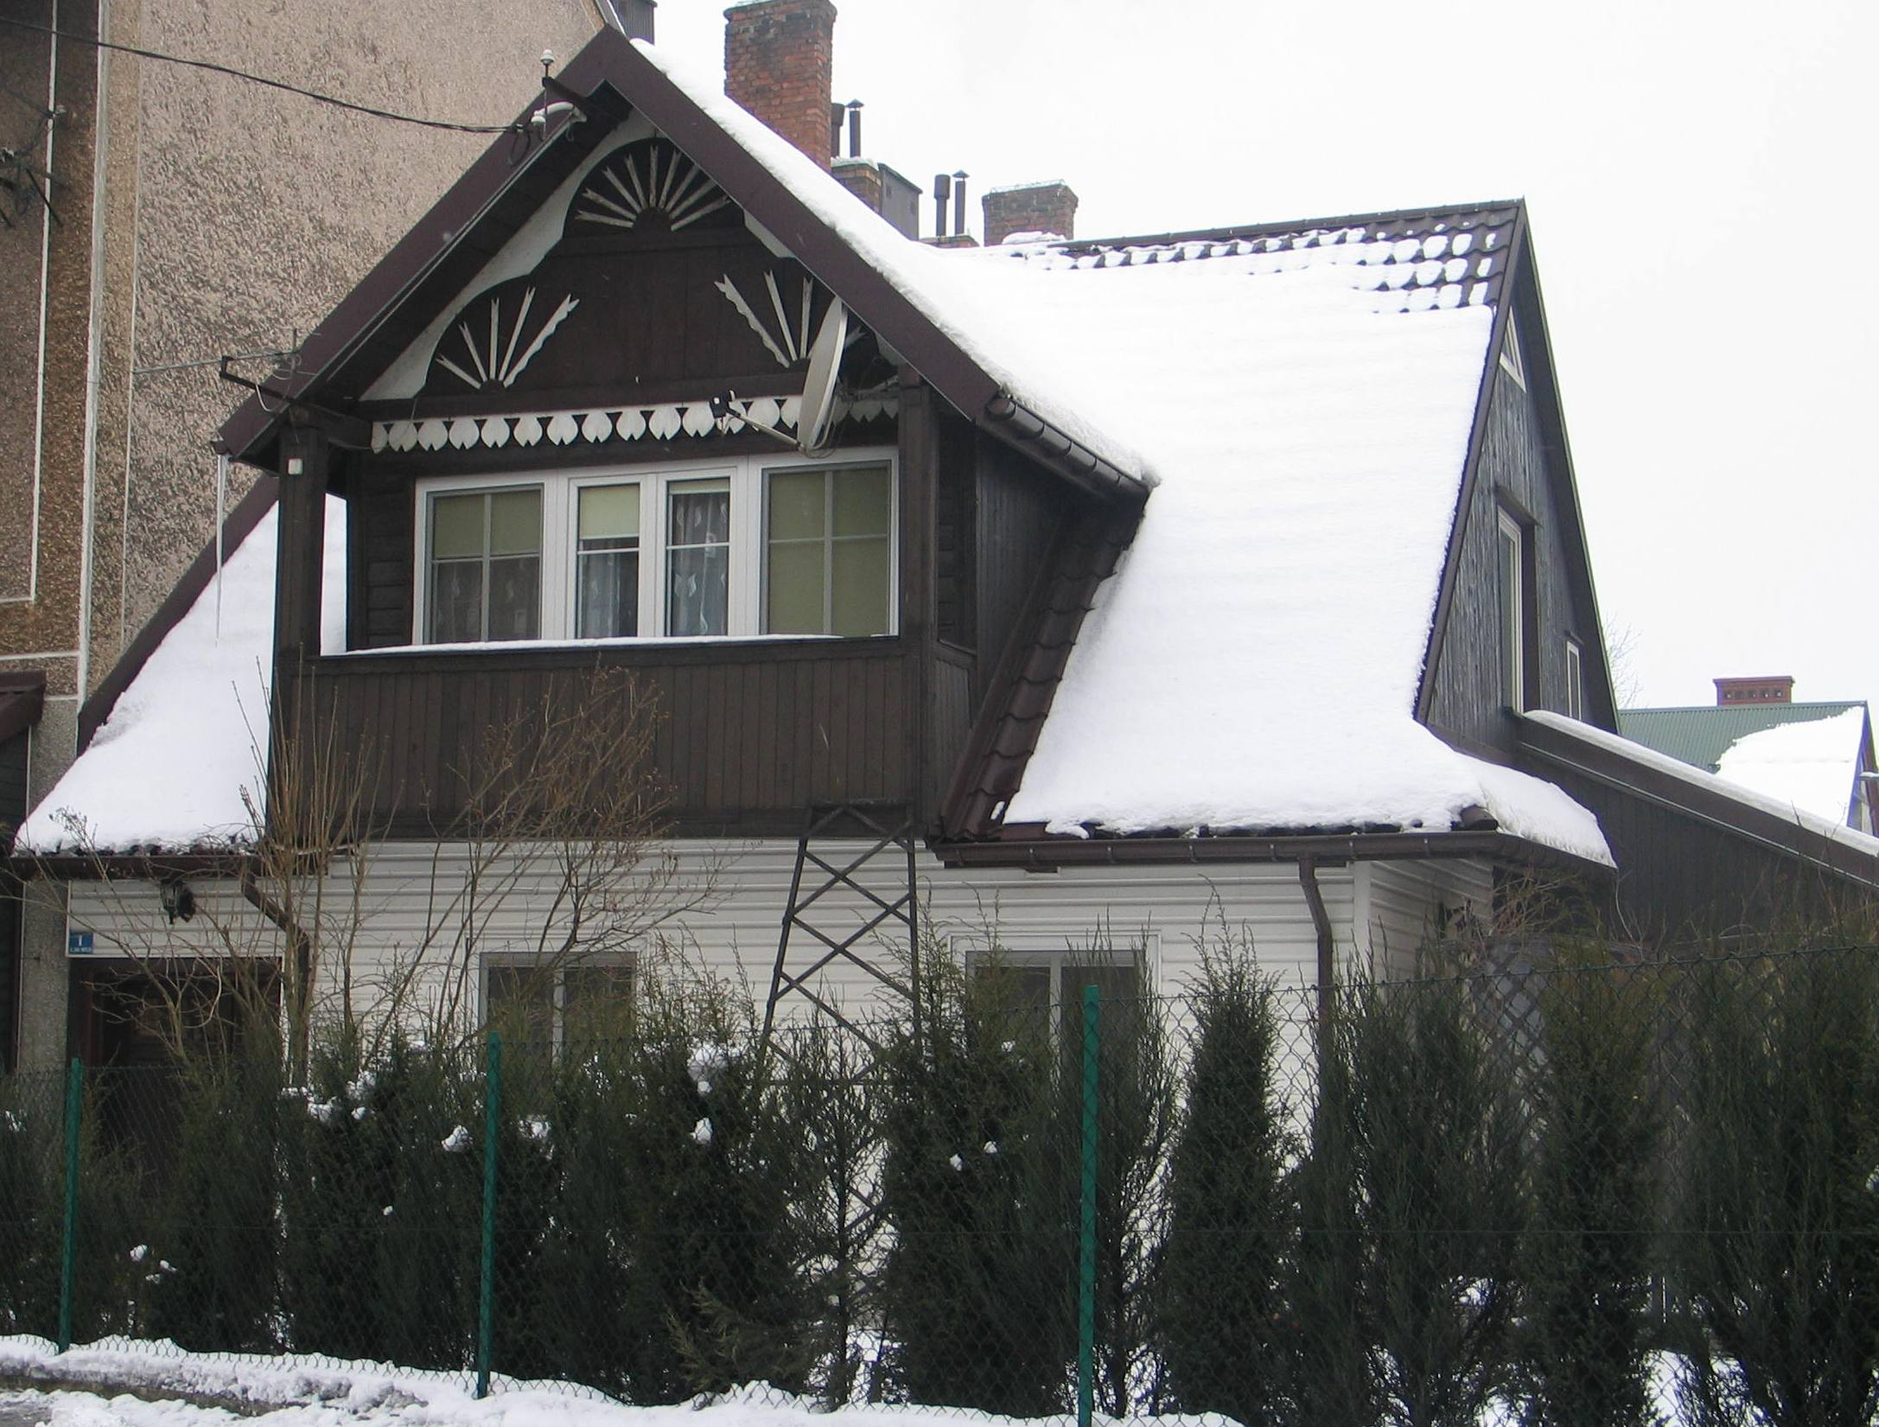
The Elusie traded cows among other things. As a boy, I often earned a grosz (a little Polish coin, before the war having quite a big value) or two for escorting cows from a market square called “Targowica” (today there is a “Centrum” supermarket) to a slaughterhouse which was where today “Wyspa Mszanka” spa centre is. For a littler one I got 5 groszes, for a bigger one – 10 groszes. The kosher slaughterhouse had been owned by Mr. Shamberger, in a building where later a delivery room was. The Shambergers had such a long chain of wooden buildings with shops and businesses, next to the later shop of Mr. Gocał. A Jewish hairdresser called Dominik had been working there. Dominik taught my older brother hairdressing and he taught him perfectly.
Saturdays I worked in a tobacco store of Mr. Weissberger. He was a reach Jew, famous for magnanimousness. He helped everyone who needed it and was generally a very good man. Many times he lent my father some money and he offered a job on Saturdays to me. The Jews didn’t work on Saturdays because of Sabbath and I also often played a role of Sabbath-boy, turning the lights on at our neighbors’. But come back to the main story. I worked at Weissberger’s shop and I remember him as a very noble man. And I still can’t forget this sad view when I saw him, old and ill, unable to walk on his own, carried on a peasant’s car to be killed that horrible day in August of 1942.

